EEG Trimmer ReadMe

1. Install the newest version of Java 8 (if not already installed)
   1. <https://www.oracle.com/technetwork/java/javase/downloads/jdk8-downloads-2133151.html>
   2. 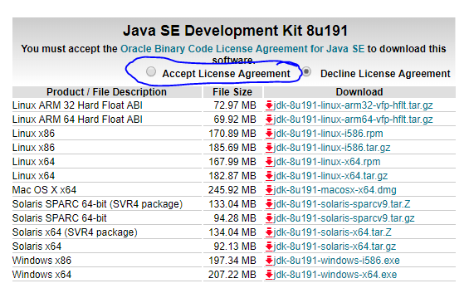Accept the License Agreement and then click the download link that matches your operating system (most likely Windows x64):
   3. When the file is done downloading, open it and follow the installation instructions. You do not need to change any of the default settings.
2. 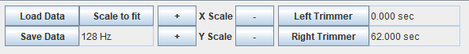Double click “EEG Trimmer Basic.jar”
3. Click “Load Data” and select your .edf file
4. “Scale to Fit” will fit all the data into the current window size
5. The “+” and “-“ buttons around the X and Y scale will zoom in and out on the data
6. “Left Trimmer” will enable the left line and “Right Trimmer” will enable the right line
7. 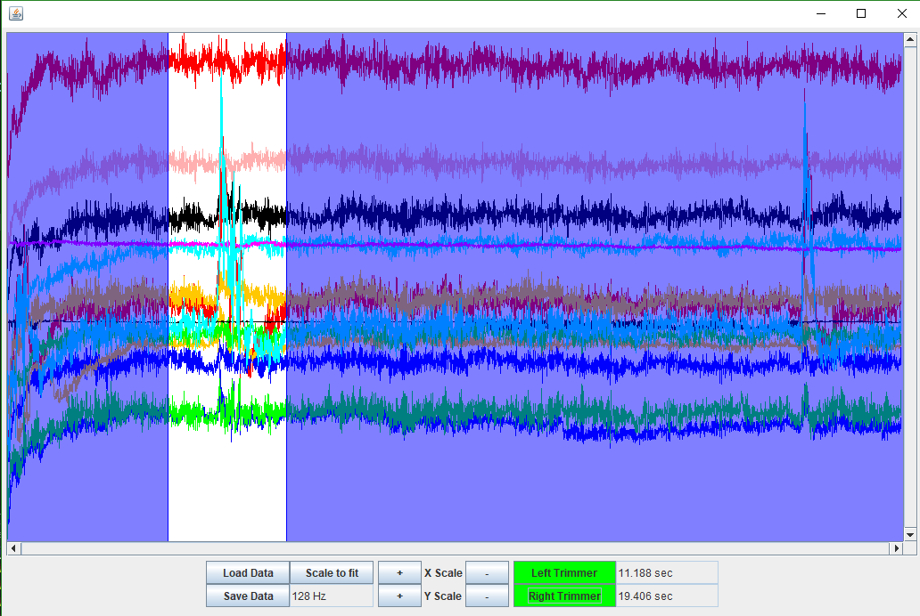Drag the line to select the data you want to trim
8. Anything highlighted in blue will be removed
9. Click “Save Data” to select where to save the

New .edf file.

1. If there are any issues please email them to:

[moneil8@vols.utk.edu](mailto:moneil8@vols.utk.edu)